ASSIGNMENT 3: Practice 3-1: Using Single-Row Functions

1) Write a query to display the system date. Label the column Date .Note: If your database is remotely located in a different time zone, the output will Be the date for the operating system on which the database resides.

SELECT sysdate "Date"

FROM dual;

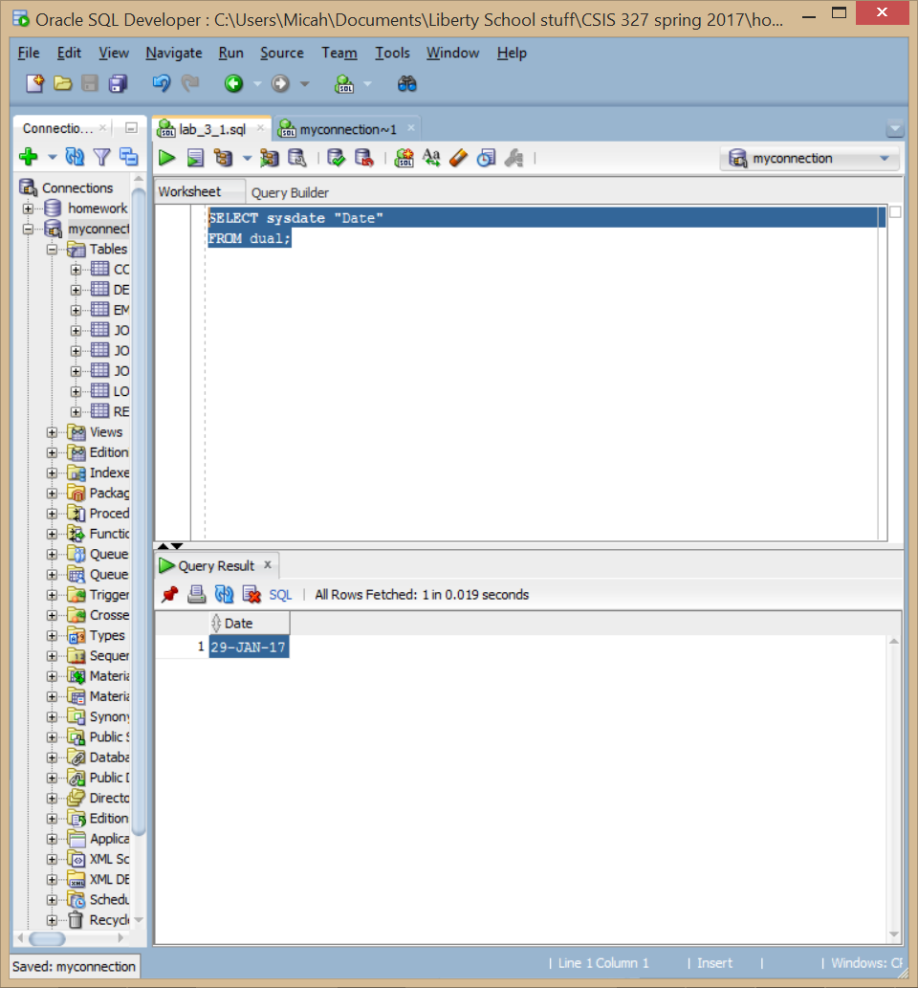

2) The HR department needs a report to display the employee number, last name, salary, and salary increased by 15.5% (expressed as a whole number) for each employee. Label the column New Salary . Save your SQL statement in a file named lab_03_02.sql .

SELECT EMPLOYEE_ID, LAST_NAME, SALARY, round (salary*1.155)"New Salary"

from EMPLOYEES;

3) Run your query in the lab_03_02.sql file.

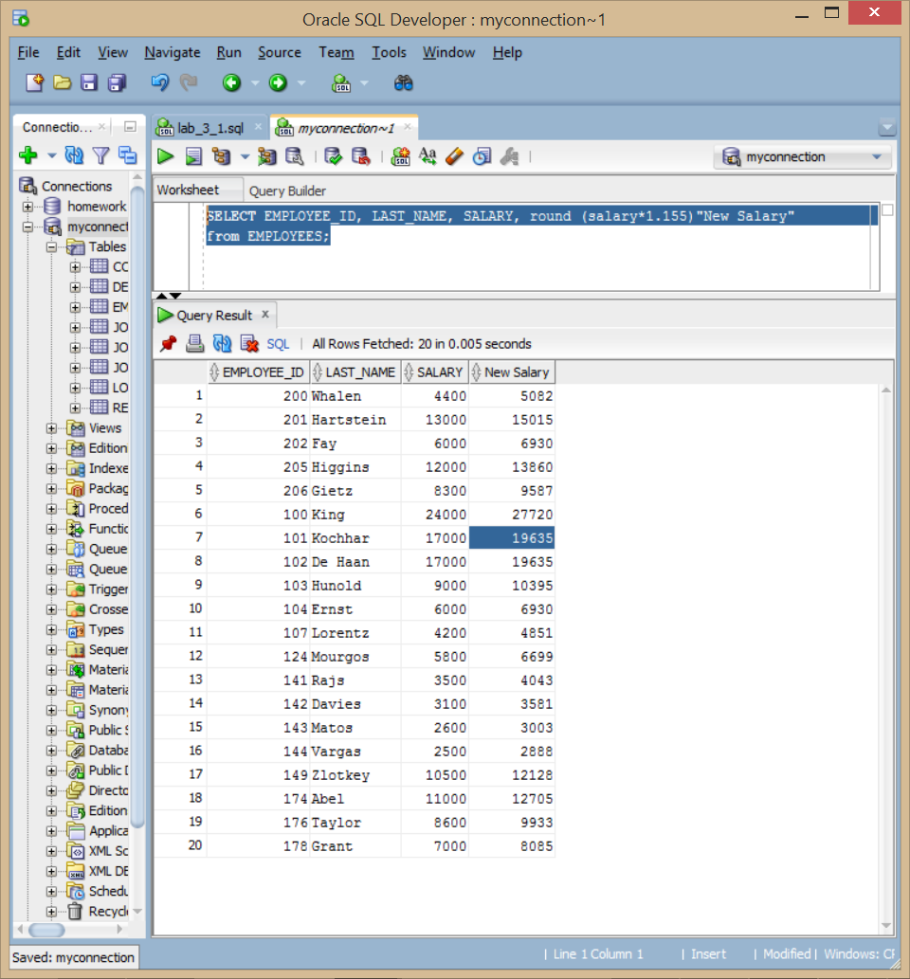

4) Modify your query lab_03_02.sql to add a column that subtracts the old salary from the new salary. Label the column Increase . Save the contents of the file as lab_03_04.sql . Run the revised query.

SELECT EMPLOYEE_ID, LAST_NAME, SALARY,

round (salary*1.155)"New Salary",

round (salary*1.155) - SALARY "Increase "

from EMPLOYEES;

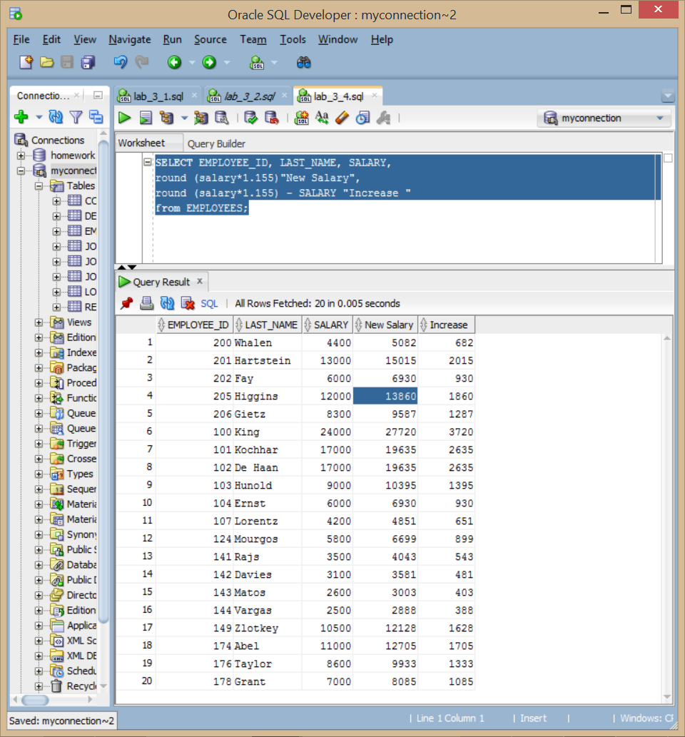

5) Write a query that displays the last name (with the first letter in uppercase and all the other letters in lowercase) and the length of the last name for all employees whose name starts with the letters “J,” “A,” or “M.” Give each column an appropriate label. Sort the results by the employees’ last names.

SELECT INITCAP(LAST_NAME)"Name", LENGTH(LAST_NAME)"# of leters in name"

from EMPLOYEES

where LAST_NAME like 'J%' or LAST_NAME like 'A%' or LAST_NAME like 'M%'

order by LAST_NAME;

Rewrite the query so that the user is prompted to enter a letter that the last name starts with. For example, if the user enters “H” (capitalized) when prompted for a letter, then the output should show all employees whose last name starts with the letter “H.” Modify the query such that the case of the entered letter does not affect the output. The entered letter must be capitalized before being processed by the SELECT query.

SELECT INITCAP(LAST_NAME)"Name", LENGTH(LAST_NAME)"# of leters in name"

from EMPLOYEES

where upper (LAST_NAME) like upper ('&Letter%')

order by LAST_NAME;

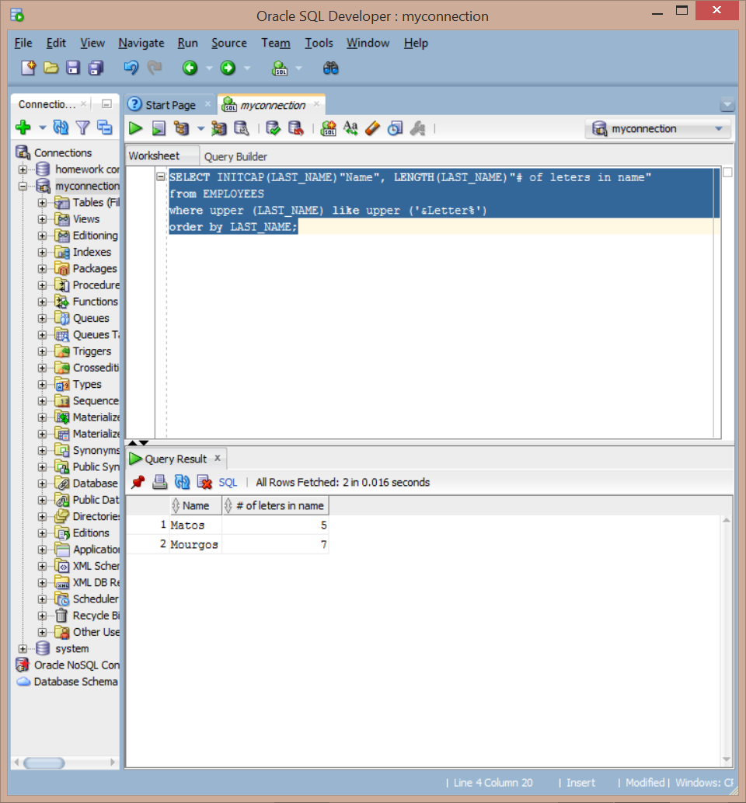

6) The HR department wants to find the duration of employment for each employee. For each employee, display the last name and calculate the number of months between today and the date on which the employee was hired. Label the column as MONTHS_WORKED . Order your results by the number of months employed. Round the number of months up to the closest whole number. Note: Because this query depends on the date when it was executed, the values in the MONTHS_WORKED column will differ for you.

Select LAST_NAME, round (MONTHS_BETWEEN( sysdate, HIRE_DATE)) "MONTHS_WORKED"

from EMPLOYEES

order by MONTHS_WORKED;

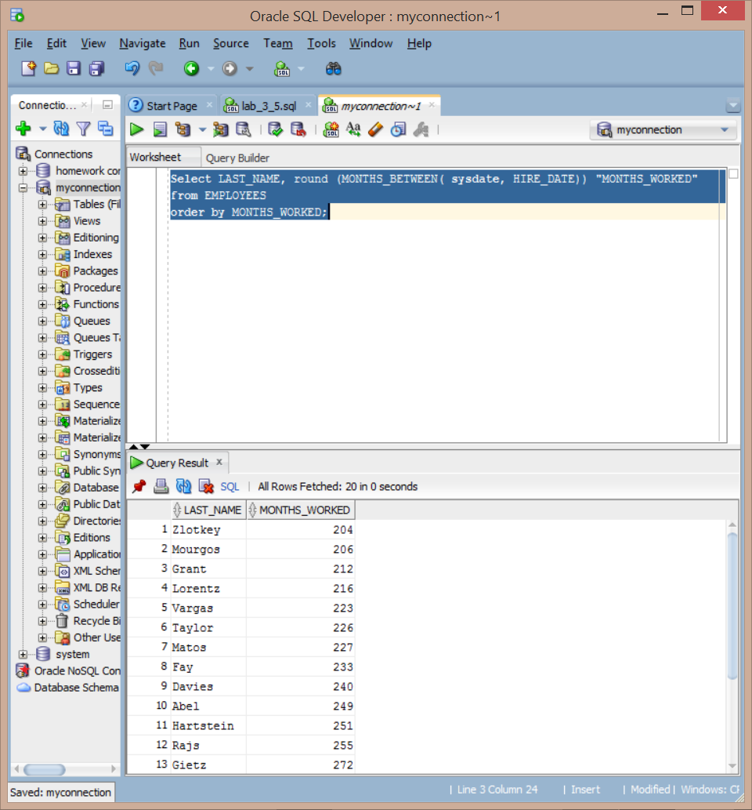

7) Create a query to display the last name and salary for all employees. Format the salary to be 15 characters long, left-padded with the $ symbol. Label the column SALARY .

select LAST_NAME, LPAD(salary, 15, '$') SALARY

from EMPLOYEES;

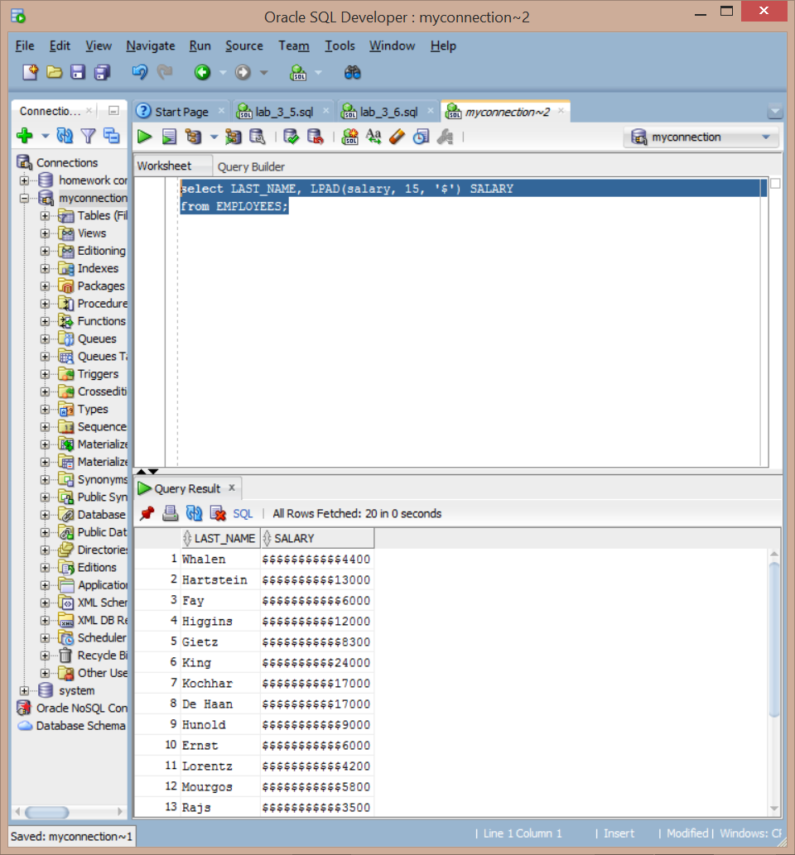

8) Create a query that displays the first eight characters of the employees’ last names and indicates the amounts of their salaries with asterisks. Each asterisk signifies a thousand dollars. Sort the data in descending order of salary. Label the column EMPLOYEES_AND_THEIR_SALARIES .

select concat (rpad(SUBSTR(LAST_NAME , 1 , 8),8,' ') ,

rpad(' ',round (salary/1000), '*')) "EMPLOYEES_AND_THEIR_SALARIES"

from EMPLOYEES

order by SALARY DESC;

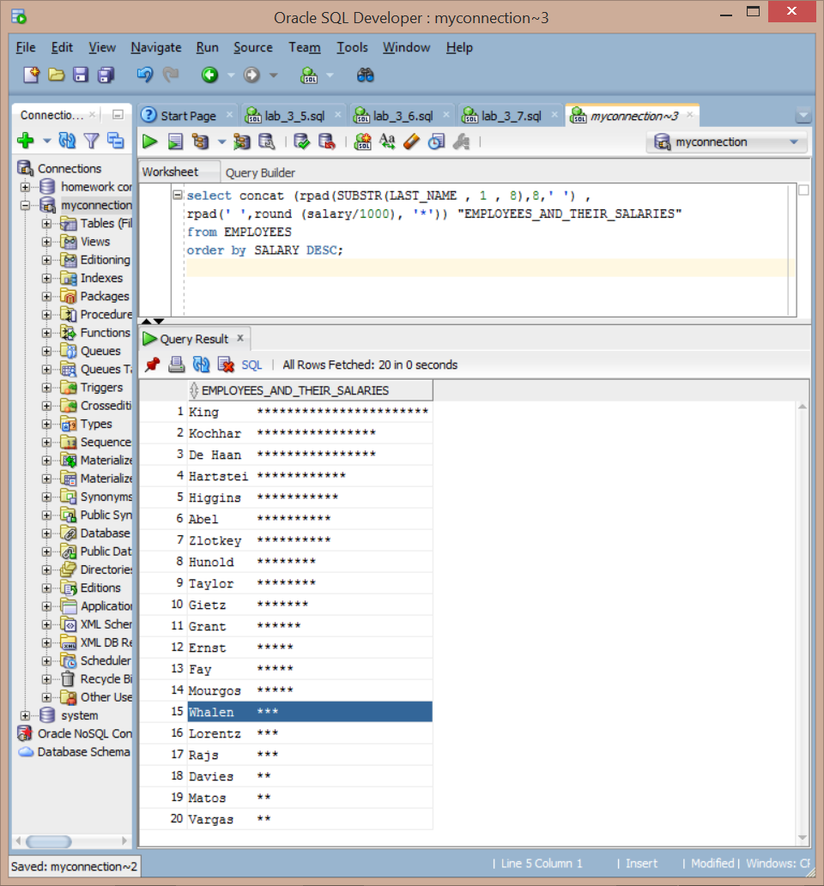

9) Create a query to display the last name and the number of weeks employed for all employees in department 90. Label the number of weeks column TENURE . Truncate the number of weeks value to 0 decimal places. Show the records in descending order of the employee’s tenure. Note: The TENURE value will differ as it depends on the date on which you run the query.

Select LAST_NAME,(trunc(sysdate,'d')-trunc(HIRE_DATE,'d'))/7 "TENURE"

from EMPLOYEES

where DEPARTMENT_ID = 90

order by TENURE DESC;

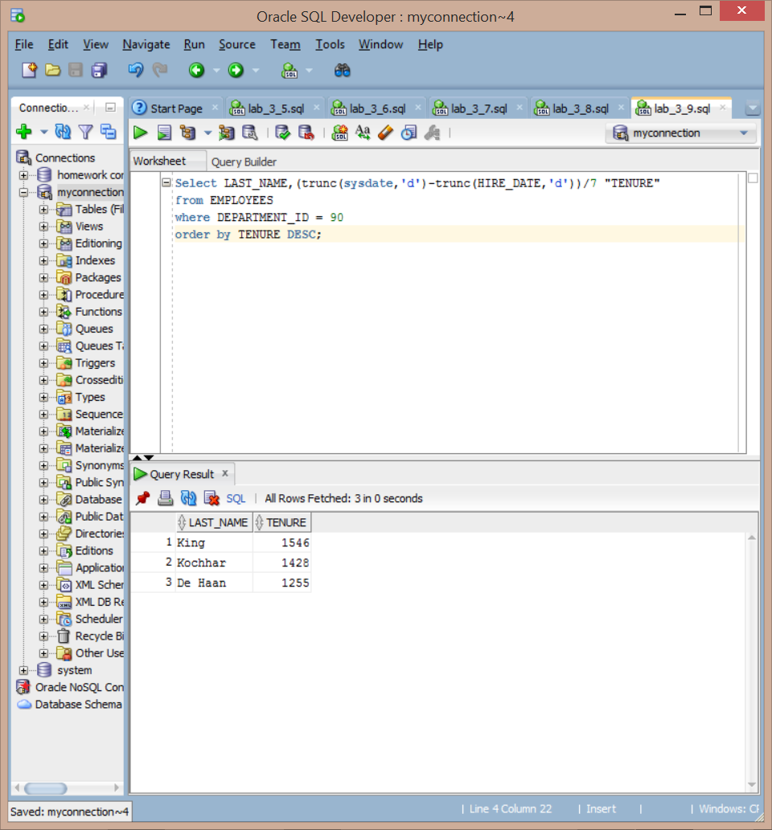

10) Using an entity relationship diagram (ERD) tool of choice, create an ERD diagram using the Crow’s foot method of the human resources schema used in the Oracle curriculum. The diagram should follow the rules of an ER diagram learned in the fundamental database course. This should include entities, attributes, relationships, descriptions, inside and outside cardinality, primary keys, and foreign keys.

